What portion of the GDP did the federal government spend as of 2016?
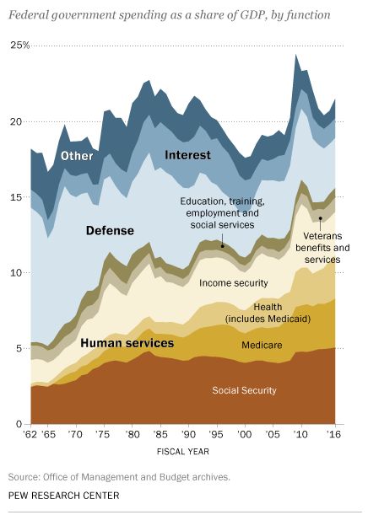

How accurate was your silly prediction?

Would you be embarrassed to share your prediction with your most special friend?

How surprised are you by the overall portion of the GDP that the federal government spends?

What other levels of government spending are not included in this chart?

How do you think this spending level compares to other advanced post-industrial countries like Switzerland, Japan, or New Zealand?

What are two trends in spending you see in the chart?

For each of the trends in question 3, explain one cause of that trend.

What is a consequence of one of these trends?

Based on the trends in the chart, what portion of GDP do you think the US government will spend between now and 2062?

How familiar are most Americans with the data from this chart?

Currently, what is the biggest single expenditure from the US government?

Why do you think that is?

Donald Trump, in his budget outline, has proposed increases in defense spending (very light blue section of chart) and decreases in "other" spending (darkest blue section of chart) for things like the NEA, NASA, and the CPB. Do you support that idea?

If you had to cut any one area of spending in this chart, explain which area it would be.

Which areas in this chart are entitlement or mandatory spending, and cannot be simply cut by a new budget?

Overall, is this chart good or bad news?

What would the framers of the Constitution think about this chart?

Former Treasury official Peter Fisher once said, the federal government is basically “a gigantic insurance company,” albeit one with “a sideline business in national defense and homeland security.” Based on the data from the chart, does Fisher's assessment seem correct?

Learning Extension

Read this swell new Pew Report putting federal spending in perspective.

Action Extension

Contact the POTUS, or if you're not at Mar-a-Lago, go to his website to share your opinion of US federal spending and what he should do about it!

Bonus Visual!!!

