What percent of Hispanic voters voted for Donald Trump in 2016?
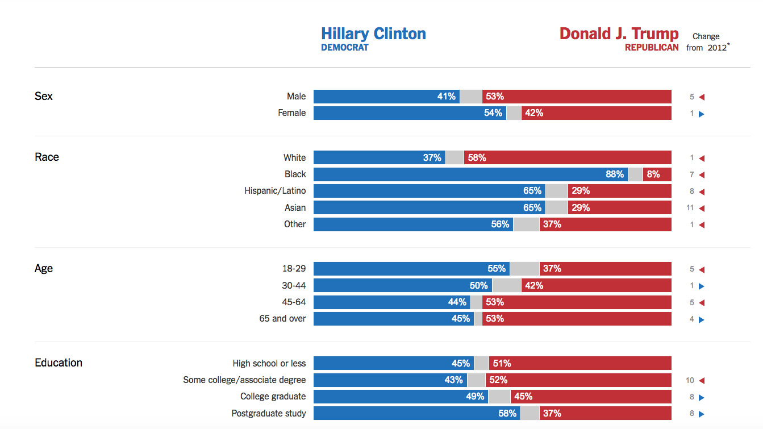
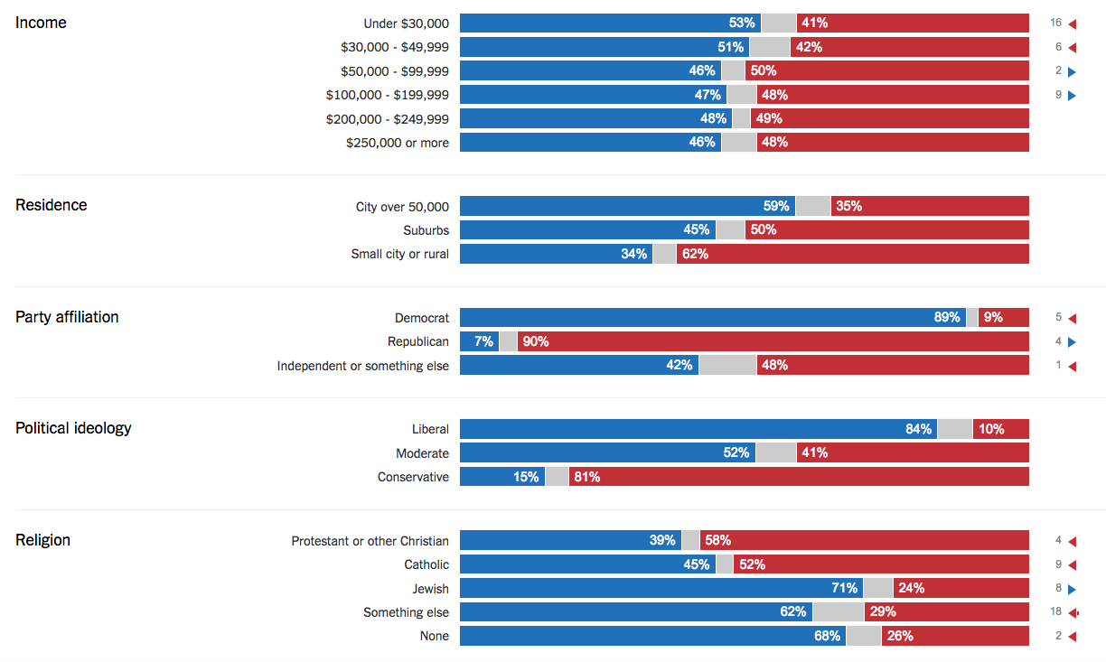
NY Times
http://www.nytimes.com/interactive/2016/11/08/us/politics/election-exit-polls.html
- How accurate was your prediction?
- What most surprised you about this information?
- Why do you think that 29% of Hispanic voters voted for Trump?
- What is one consequence of this?
- In your opinion, is this chart generally good or bad news?
- Based on the chart, what do you think is the number one demographic reason that Donald Trump won this election?
- Which demographic group from the chart above gave Clinton the most support?
- What are some other important trends you see in the chart?
- Which of the demographic groups from the charts above is the largest in total number?
- Which groups did Hillary Clinton have more success with in 2016 than President Obama did in 2012?
- Why do you think that is?
- Flipping the vote of which group would have most quickly changed the entire outcome of the entire election?
- What does this information tell us about the next few U.S. presidential elections?
- Based on this data, what advice would you give a democratic party operative hoping to win in 2020?
- Does politicians' knowledge of all this information affect the way we run US political campaigns?
- Why do you think Whites were so reluctant to support Clinton in 2016?
- Above all, what do you think the 2016 election was about?
- Explain whether you agree with the Trump protestors?
- A few days out, explain your opinion of the election on the comments section below or on Twitter with #apgopo

Learning Extension

There's a whole lot more information in this interactive 2016 exit polls chart at NYTimes. And you can even scroll from year to year to compare American demographics and voting changes. Take a look!

Action Extension

Based on the exit polling data, create the most over the top Trump supporter and most over the top Clinton supporter imaginable. Share these 2016 hyper-partisans with us on social media and in class.

