What is the most selective college in your state?
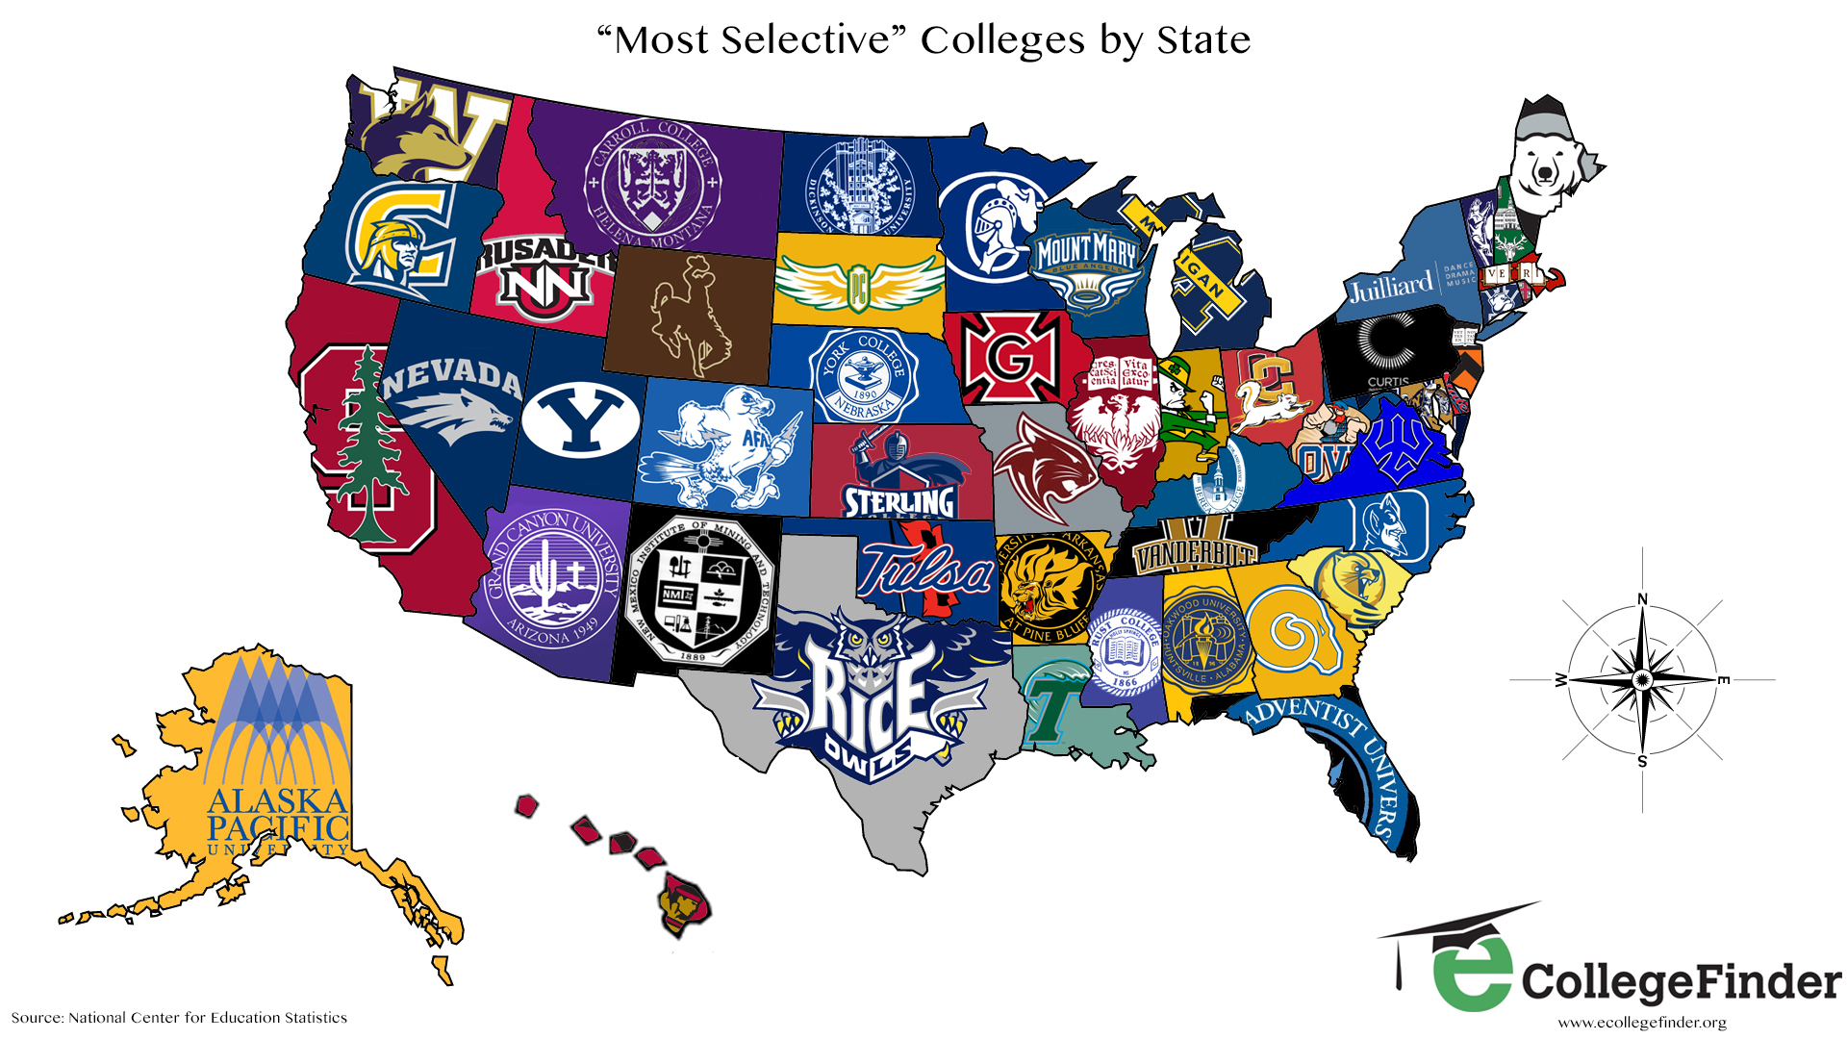

How accurate was your prediction?

What was most surprising about this information? What was the least surprising about this information?

How many of these most selective schools had you never heard of before?

How many of these schools have you applied to?

What about these most selective schools makes so many people want to apply to them?

Are the most selective schools always the best?

Do you think the government should work to make college more affordable?

Most of these most selective schools are private. Most of them cost tens of thousands of dollars a year to attend. In many other wealthy countries, public education is free or almost free. The US is home to some of the world's best schools, but most of them are extremely hard to afford. What is your opinion of this US university system?

In general, do you think that college is a good investment?

What do you think is the most important factor when considering what college to attend?

Talk to an adult you really admire and ask them about their university experience.

Learning Extension

Browse the US News list of the most selective colleges in the US for 2016.

Action Extension

The more applications a college gets, the more selective it become. Let's all apply to Kalamazoo College and see what happens to their selectivity ranking.

