What are the ten most common U.S. surnames (last names)?

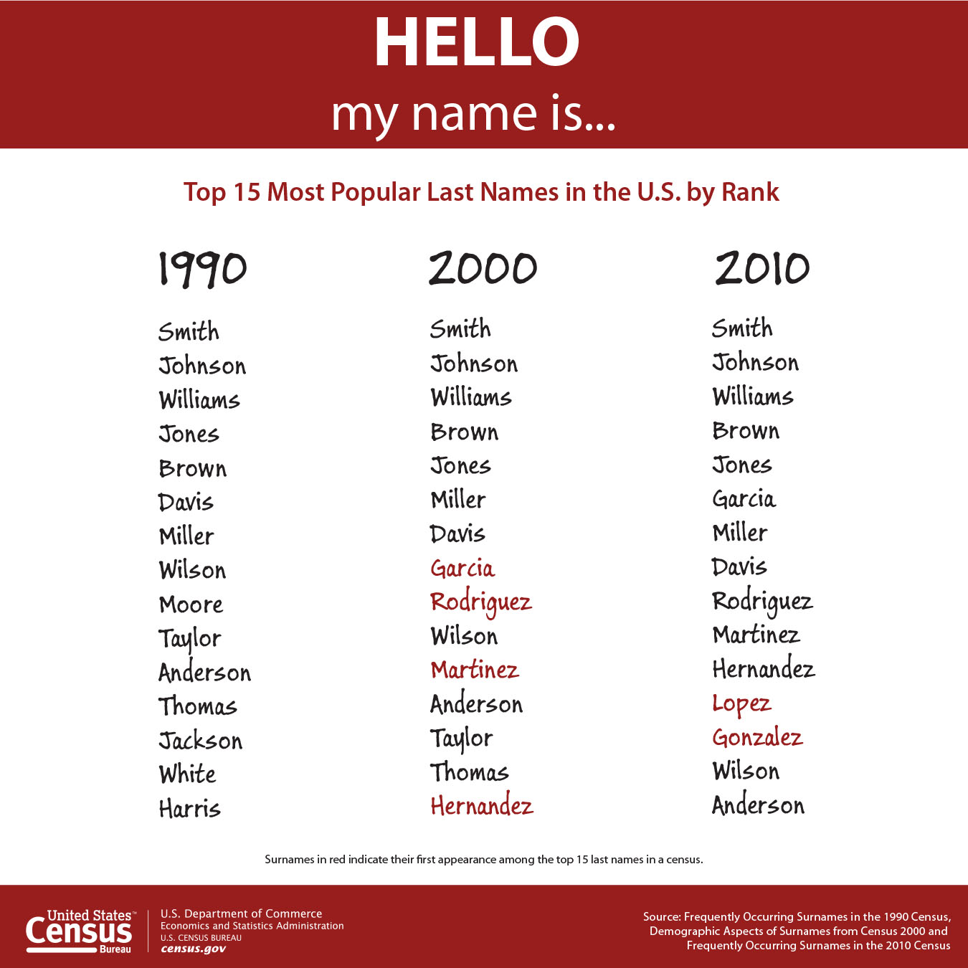

How accurate was your prediction?

Is your surname on this list?

If you could change your last name to any last name you wanted, what would your new surname be?

What most surprised you about this list?

What is the big story this chart tells?

What ethnic group has made the biggest increase in this list over the past three decades?

Overall, what are the most important changes to this list over the past three decades?

Why do you think that is?

What is a consequence of this?

How will the growing Hispanic demographic affect U.S. politics in the future?

Are these changes good news or bad news?

How do you imagine this list will change for the 2020 census?

What is the next ethnicity/nationality that you think will be added to this list and when will that happen?

Imagine that there was a census in the year 1490 in what is today the Unite States (and yes, I know, the US wasn't a country then, the first census didn't happen until 1790, and they couldn't speak English back then, blah, blah, blah. This is hypothetical!) What do you imagine those names would have looked like? And what would those names have looked like in 1700?

Is it possible to stop time, to make things never change?

If we built a beautiful huge wall between the U.S. and Mexico what would that do to the Hispanic population in the U.S.?*

Bonus Chart
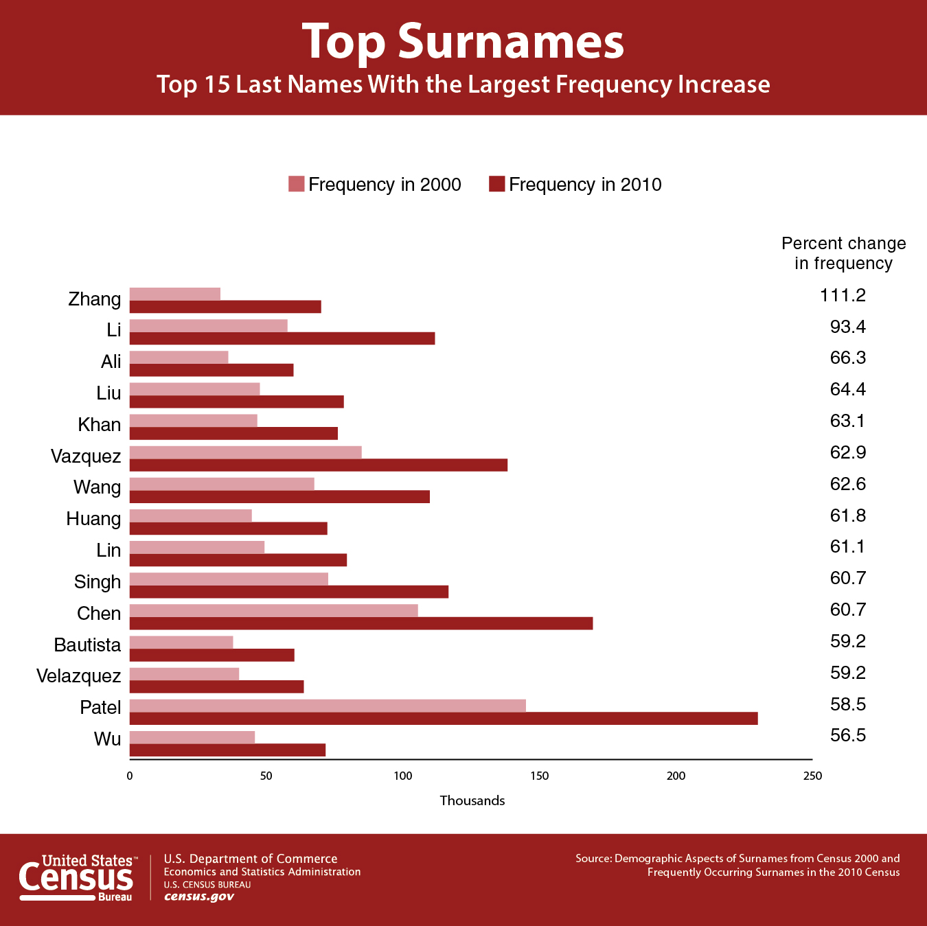

Learning Extension

Many last names come from occupations. Check out this last name website and see if you can figure out where your name came from.

Action Extension

Ask a random 15 people to tell you their last name. Compare your list with the US list. How are they similar? How are they different? Why do you think that is? Share your names in class and compile a class master list of the top fifteen surnames. Share your class data on social media and discuss.

*Because there is currently net migration OUT of the US and INTO Mexico, a wall would actually increase the Hispanic population in the U.S.

