What percentage of Americans answered yes to the following question: "Is it the responsibility of the federal government to make sure that all Americans have health care coverage?"
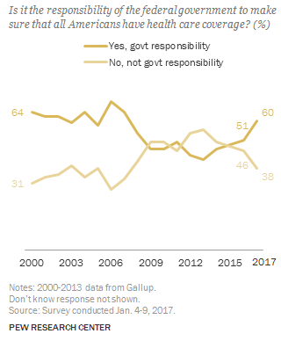
- How accurate was your prediction?
- How surprising is this information?
- What is one trend do you see in the chart?
- What do you think explains this trend?
- What is the big story the chart tells about how Americans feel about health care coverage at the current moment?
- Why do you think almost 2/3 of Americans think all Americans should have health care coverage?
- Given that almost 2/3 of Americans think all Americans should have health care coverage, why don't all Americans have health care coverage?
- How do you personally answer the following question: Is it the responsibility of the federal government to make sure that all Americans have health care coverage?
- Explain your answer:
- If you were a member of the US Congress and you saw this information would you be likely to support health care coverage for all Americans?
- House Republicans have repeatedly voted to repeal the Affordable Care Act (Obamacare). Explain whether you think they will replace it with health care coverage for all Americans.
- The Affordable Care Act (Obamacare) added 22 million people to the rolls of those with health care coverage. According to a study by the Robert Wood Johnson Foundation, a repeal of Obamacare will result in 24 million people losing health care coverage. Given that a majority of Americans want universal health care coverage, and repealing Obamacare will result in a loss of health care coverage, do you think repealing Obamacare is a good idea for our nation?
- What are some checks the different branches of government have on US health care policy making?
- What question do you have about this?
- What would be one cost of having universal health care?
- What would be one benefit of having universal health care?
- How many countries have health care for all (universal health care)?*

Learning Extension

Read the Robert Wood Johnson Foundation report on the cost of repealing the Affordable Care Act.

Action Extension

Contact your US House Representative and share your opinion of the responsibility of the federal government to make sure that all Americans have health care coverage.

Bonus Charts
