Do more U.S. voters cast a straight-ticket* or a split-ticket ballot?

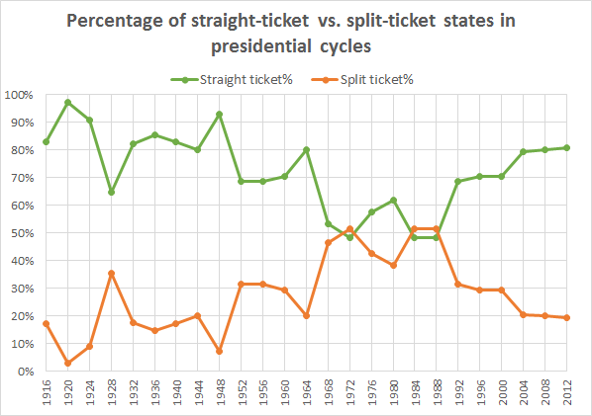

How accurate was your prediction?

Does this information surprise you?

What trend do you see in the chart?

What do you think explains that trend?

What is one consequence of that trend?

Is that good news or bad news?

How will this affect this year's election?

Which party do you think is more worried about this trend right now?

Is it possible to cast a split-ticket in a midterm election?

Do you think that split-ticket voting is a bad idea?

Would you vote a split-ticket?

Learning Extension

Check out these cool charts on split-ticket voting from WAPO.

Action Extension

Talk to people until you find someone who is planning (or would if they could) a split-ticket vote. Try to understand why they are splitting their ticket and share your conversation with the class.

*Straight-ticket voting (also called straight-party voting) allows voters to choose a party’s entire slate of candidates with just a single ballot marking. Voters make one punch or mark on the ballot in order to vote for every candidate of that party for each office on the ballot.

