Who represents more people, a US Senator from Wyoming or a Los Angeles County Supervisor?

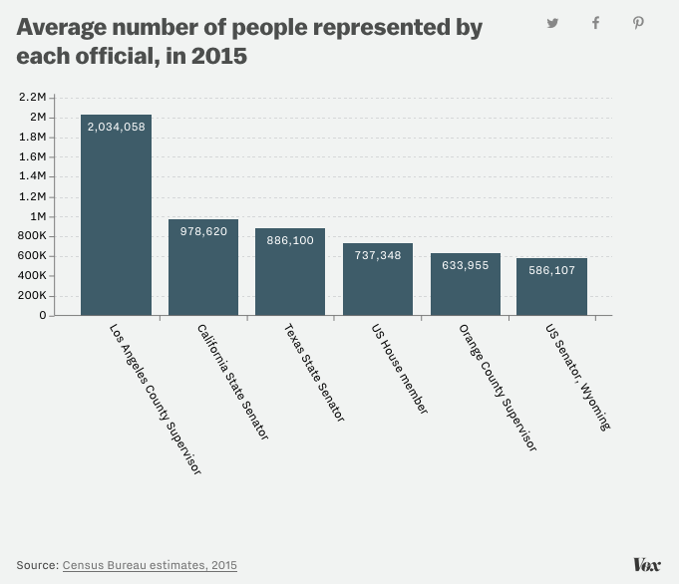
- How accurate was your prediction?
- What most surprised you about this data?
- What is the BIG PICTURE this data paints?
- Why is that?
- What is a consequence of that?
- While LA County Supervisors represent more people than a WY Senator, (or, in fact than Senators from Nebraska, West Virginia, Idaho, Hawaii, Maine, New Hampshire, Rhode Island, Montana, Delaware, South Dakota, Alaska, North Dakota, and Vermont), explain whether political power is based solely on the number of people a politician represents?
- What are some powers that county commissioners (supervisors) have in your county?
- What are some powers US Senators have that LA County Supervisors (or most supervisors, in general) don't?
- Explain whether you would rather be a US Senator from Wyoming than an LA County Supervisor:
- Are there any politicians in your state who represent more people than an LA County Supervisor?
- What questions do you have about this data?
- If you could hold any position at any level of government in America, explain what position you would want:
- Explain what you believe politicians should do for the people that voted against them: (Do they represent them too? Should they follow their will?)
- The United States gives all people equal representation through the House of Representatives (each district is roughly equal), and all states equal representation through the Senate (two Senators per state). Since democracy means government by the people, where all people are equal, is it democratic to give each state equal representation if that means that smaller states (and all the people in them) have more representation than larger states?
- Explain whether you believe a representative government can function successfully in a country the size (>318,000,000 people) of the United States:

Learning Extension

Because California gives a considerable amount of power to counties, that makes supervisors very, very powerful. Indeed, Hilda Solis, another member of the LA County Board of Supervisors, stepped down as US secretary of labor to run for it. You read that right. Solis — a former Congress member to boot — resigned a Cabinet position because she wanted to take a job in county government. And it makes sense — she represents more people than a senator from a small state.

Action Extension

I've heard a lot of people complaining about this year's presidential election. Calculate the first year you could run for president (35 age minimum), Senate (30), US House (25), and local offices (?), and go to Candidate College to plan your run for office!

