What percentage of Americans worry "a great deal" about the problem of race relations?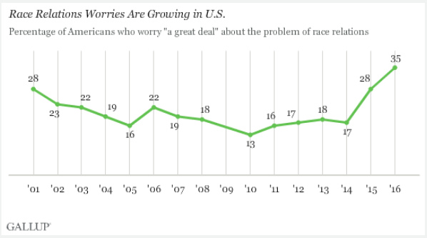

How accurate was your prediction?

What most surprised you about this?

What is the big story this chart tells?

Why do you think that is?

If the current trend continues, what will this chart look like in 10 more years?

Explain whether this is good news.

What questions do you have about this data?

How much do you worry about race relations in the US?

2008 brought the US its first Black president. What affect did the Obama presidency have on this chart?

Explain any connection between this chart and the rise of Donald Trump.

How do you think the Trump presidency will affect race relations in the US?

In 2008 95% of Black voters voted for Barack Obama; in 2016, 8 percent of Black voters chose Donald Trump. Explain this huge racial voting gap.

List one policy the government could implement that would greatly improve race relations in the US:

Democrats worry about race relations more than Republicans, Black more than Whites. Why do you think that is?

Explain whether you believe Americans should worry about race relations.

Learning Extension

Check out the Gallup Report on American's attitudes about race relations.

Action Extension

Use this super-cool interactive exit polling data site to draw conclusions about race relations in the US. Are we the United States or not? Share your opinion in class or online.

Bonus Chart
