What percent of Americans age 18-29 think that FATHERS should receive paid leave following the birth or adoption of their child?

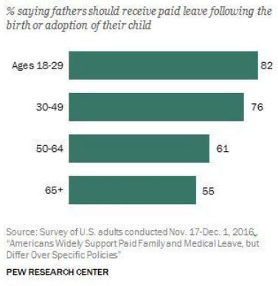
- How accurate was your prediction?
- What most surprised you about this?
- How much does age determine a person's support for paid paternal leave?
- How different do you imagine the answer would be if we changed the word fathers to MOTHERS?
- How different do you imagine the answer would be if we changed the word paid to UNPAID?
- How different do you imagine views on paternity leave are between Democrats and Republicans?
- Currently, neither men nor women are mandated a paid paternal leave by the US government. Why do you think that is?
- Do you think that is a good thing?
- Most modern post-industrial countries give some amount of paternity leave. Why do you think the US does NOT give paid paternity leave?*
- What is one positive consequence of not having paid paternal leave?
- What is one negative consequence of not having paid paternal leave?
- How does the US compare to other nations in terms of paternity leave?*
- How might US federalism complicate the issue of a universal paternity leave from the US government?
- Imagine you wanted to change the rules of paternity leave in the US. What part of the US bureaucracy would be tasked with these sorts of rules?
- In the comments section below, explain whether you personally think the US should grant paid leave to mothers or fathers.

Learning Extension

Read this article from The Week about how the US ended up with the worst maternity leave laws on earth.

Action Extension

Contact your US Senator and share your opinion about paid paternity leave.

Bonus Visuals*
