How much $ was spent to lobby the U.S. government in 2016?
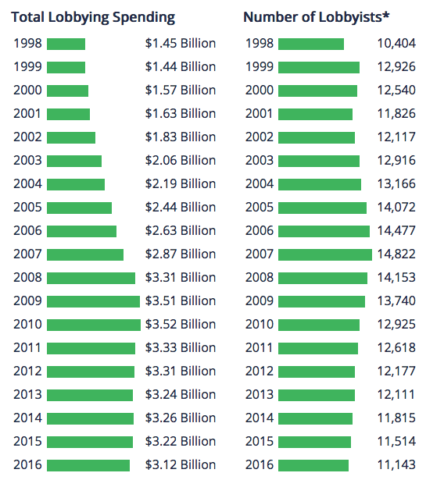
Center for Responsive Politics
- How accurate was your prediction?
- Surprised?
- What adjective would you use to describe the amount of money spent on lobbying?
- If you were to buy pizzas with the money spent on lobbying Congress in 2016, and each pizza cost $12, how many pizzas could you buy?
- Is all this lobbying legal?
- Who makes the rules about the legality of lobbying?
- Who benefits from this lobbying?
- Who doesn't benefit from this lobbying?
- Some lobbyists work for groups like the Red Cross, the Sierra Club, or the National Educators Association! Others work for weapon manufacturers, golfers associations, or tobacco companies. Overall, do you think that lobbyists have a positive impact on US politics?
- What big story does the data tell?
- Why do you think spending on lobbying has doubled in less than 20 years?
- What is the most important consequence of all this money spent on lobbying?
- How specifically does lobbying affect elections in the US?
- What do lobbyists actually do?
- If you were to become a lobbyist, what group or company would you want to lobby for?
- Imagine that lobbying and lobbyists were outlawed. How would the US political system most change because of this?
- Is this data good or bad news?
- Why do these groups and businesses spend all this money to lobby the government?
- What group spent the most money on lobbying in 2016 and how much did they spend?*
- What sector of industry spent the most on lobbying in 2016?**

Learning Extension

Read the report and check out the groovy graphs and charts about lobbyists, money and politics from Open Secrets!

Action Extension

There are a number of issues where you can take action at the Open Secrets action page:
- Disclose Donors to Presidential Libraries
- Require Companies to Disclose Political Contributions
- Preserve Reporting Requirements for Nonprofits
- Access to CRS Reports
- Access to Congressionally Mandated Reports
- Bring Leadership PACs Into Line

Take one action and share your results online or in class.

Bonus Chart*
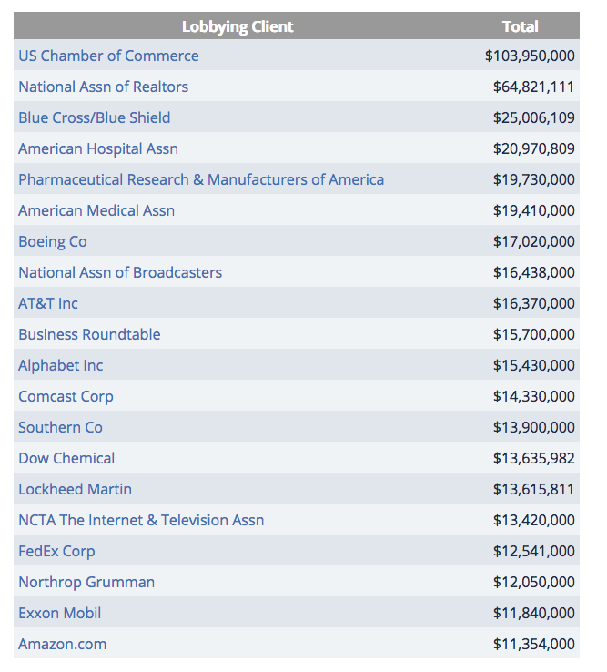

Bonus Chart**

