In 2010, what percent of Americans were not born in the U.S, and how does that % compare to the rest of the world?*
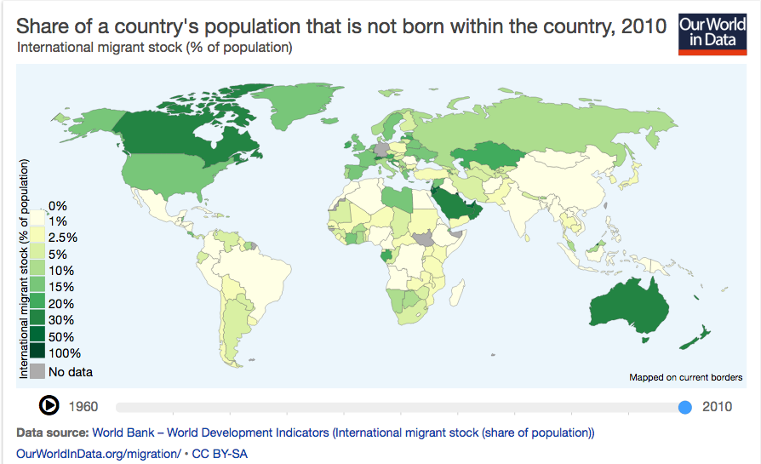

*In 2010, 13.84% of Americans were not born in the U.S. In 1960, it was 5.99$.

How accurate was your prediction?

What most surprised you about this data?

Explain one cause of almost 15% of the American population foreign born:

Explain one consequence of almost 15% of the American population being foreign born:

Explain whether it is good or bad that almost 15% of Americans are foreign born.

What is one political consequence of having such a historically high level of foreign born population?

How do you think this historically high level of foreign born Americans affected the 2016 election?

Do you think that all people born in America should automatically get citizenship?

What parts of the US government have a say in making U.S. immigration policy?

What are the top home countries of foreign born Americans?**

Identify any geographical patterns of foreign born population %s across the globe:

Beyond America, what are some global factors that are influencing such a high level of worldwide migration?

"The more immigrants the better." Explain your opinion of this statement:

Learning Extension

Go to the Our World In Data website and use their wicked cool interactive tools to watch the rate of change of foreign born populations over the past half century. Pretty nifty, huh?

Action Extension

America has long been a country of immigrants. Contact the White House and let them know whether you think they should build walls or bridges with the rest of the world, encouraging or discouraging more immigration.

Bonus Graph**
