What states have the highest percentage of population living in economic distress?
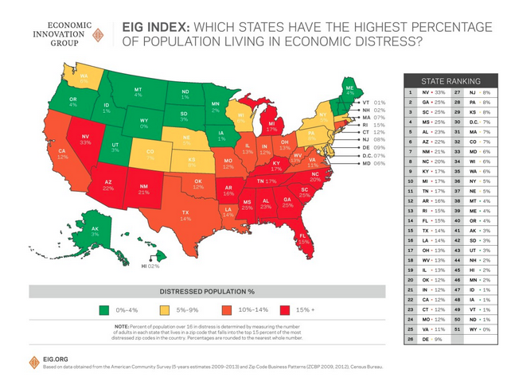

- How accurate was your prediction?
- What most surprised you about this map and information?
- What region of the US is the most economically distressed?
- Why do you think that is?
- What is one consequence of this?
- Is this map good news?
- How different do you think this map would look in other wealthy countries like Canada or New Zealand, for example?
- Explain the relationship between federalism and economic disparity within states:
- How do you think these levels of economic distress impact voting and political party identification?
- According to this map, what part of the country has the lowest percentage of people living in economic distress?
- What could the federal government could do to try to even out poverty levels between states?
- How do you think this report defines and would you define economic distress?*
- Would you say that your state is correctly classified by this map?
- How do you think race and ethnicity relates to this map?
- Will Hillary Clinton win any of these most economically distressed states in the 2016 presidential election?

Learning Extension

Read the entire EIG Report on American Communities in economic distress.

Action Extension

Compare a map of party affiliation and see how it compares to the map above. Print out and post both maps on a poster board along with a title and post it in your classroom or hallway and discuss with your friends.

*The EIG report calculates what it calls a "distressed community index" using seven metrics: housing vacancy rates, the number of adults working, the poverty rate, median income, the number of people with high school degrees, the change in employment and the rate of business formation.

In the one-fifth of ZIP codes found to have the most distressed scores, 55 percent of adults are not working and nearly one-quarter have no high school degree.
